Project Proposal – Care & Share Foundation Website
Name: Tuelo Munzhelele
Student Number: ST10480460
Module Name: Wed Development (Introduction)
Module Code: WEDE5020

Table of Contents
- Organization Overview
- Website Goals and Objectives
- Current Website Analysis
- Proposed Features
- Design and User Experience
- Technical Requirements
- Timeline and Milestones
- Budget Estimate
- References

1. Organization Overview
Name: Care & Share Foundation
Brief History: Founded in 2015, Care & Share Foundation is a community-driven non-profit organization dedicated to helping underprivileged individuals and elderly people. The foundation’s work extends into schools, where it provides essential resources such as school shoes, uniforms, stationery, and other learning materials to children in need. In addition to educational support, the organization regularly distributes food parcels, blankets and hygiene supplies to elderly residents and struggling families. Through partnerships with donors, volunteers and local businesses, Care & Share Foundation has built a reputation for delivering practical, impactful assistance that uplifts the community.
Mission Statement: To restore dignity, opportunity, and hope by providing essential supplies, educational resources, and community support to those in need.
Vision Statement: To create a compassionate society where every child has the tools to learn and every elderly person is cared for with respect.
Target Audience: Underprivileged school children, low-income families, and elderly individuals in Mahikeng and surrounding areas.

2. Website Goals and Objectives
- Goals:
  - Create a professional online platform to highlight the foundation’s mission and activities.
  - Make it easy for people to donate, volunteer, or request assistance.
  - Share impact stories and updates to inspire community involvement.
- KPIs:
  - Increase in online donations and volunteer registrations.
  - Growth in website traffic from local and national audiences.
  - Engagement on campaign and event posts.

3. Current Website Analysis
Currently, Care & Share Foundation relies on social media platforms for communication. While effective for quick updates, it lacks a central hub for donations, event details, and resource requests, which limits its reach and operational efficiency.

4. Proposed Features
- Pages: Home, About Us, Our Work, Get Involved, Donate, Contact.
- Secure online donation system.
- Volunteer sign-up form.
- Photo and video gallery showcasing community outreach.
- Blog for campaign updates and success stories.

5. Design and User Experience
- Color Scheme: Warm and welcoming tones — soft blue for trust, cream for clarity, and golden yellow for hope.
- Typography: Clear, accessible sans-serif fonts for all content.
- Layout: Clean design with large visuals of outreach programs.
- Navigation: Simple top menu with clear call-to-action buttons (“Donate” and “Volunteer”).
- Wireframe Concept: Homepage with mission statement, featured projects, and donation link; dedicated pages for volunteering and stories.
- Wireframe

- Sitemap
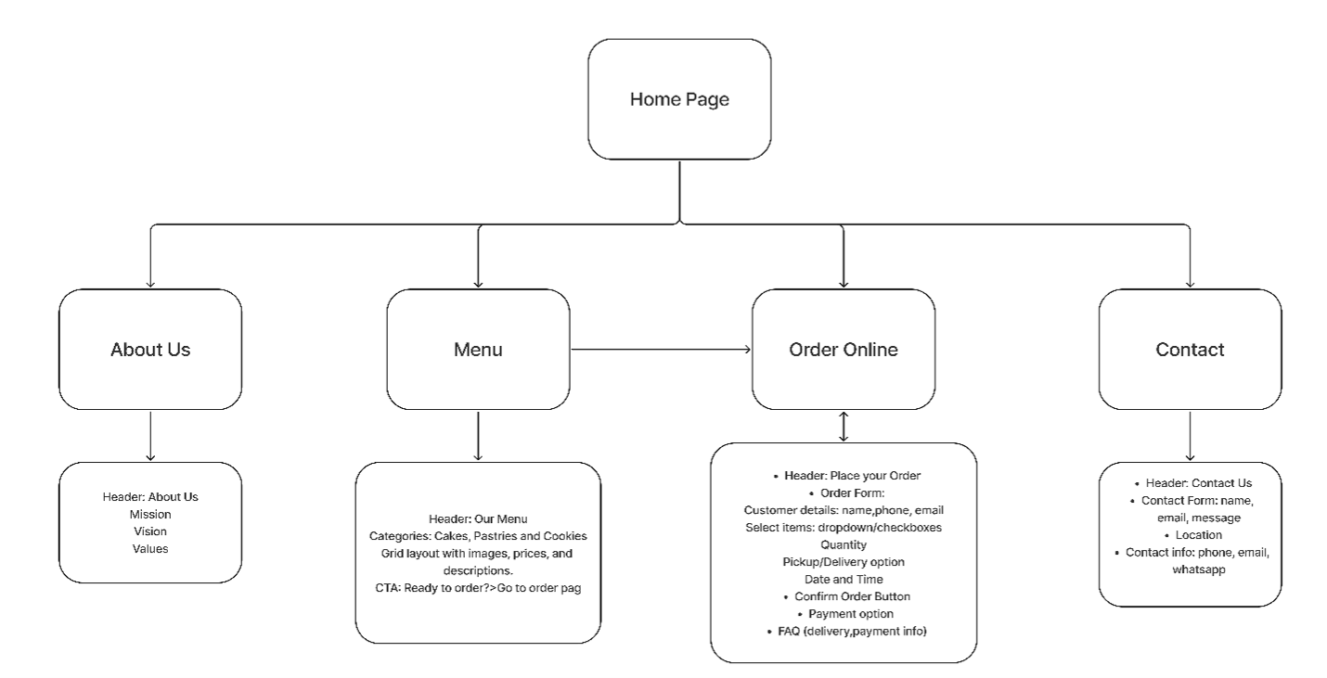

6. Technical Requirements
- Domain name (.org or .co.za).
- Hosting with SSL security.
- HTML, CSS, JavaScript; optional CMS (WordPress) for easy updates.
- Payment gateway integration (PayFast or PayPal).

7. Timeline and Milestones
- Week 1–2: Content collection, wireframe design.
- Week 3: Design approval.
- Week 4–5: Development and integration of donation system.
- Week 6: Testing and launch.

8. Budget Estimate
- Domain & Hosting: R1,200/year.
- Development: R5,500 (once-off).
- Maintenance: R500/month.

9. References
South African Government, 1997. Nonprofit Organisations Act 71 of 1997. [online] Available at: <https://www.gov.za/documents/nonprofit-organisations-act> [Accessed 27 August 2025].
WildApricot, 2025. 15 nonprofit website best practices for design, SEO and engagement. [online] Available at: < https://www.wildapricot.com/blog/nonprofit-website-best-practices> [Accessed 27 August 2025].
.

